Name:  Teacher : | ____________________________________  ______________________ |  | Date:_________
 | Year 12 Essentials – Practical Application  Fitting Furniture in a Room  Conditions: 1 lesson in class and 1 week to take home.  Weighting 7% Due Date: ____________ | Mark _________

A well laid out room makes it easier to move around as well as feeling better to work in. This means making sure that there is adequate space to move around and that lines of sight are not blocked wherever possible.

James is building a new house. You will need to identify common items of furniture for a combined living/dining room, select appropriate items and create a floor plan showing two alternatives for fitting them into a room but still having space to move around.

You need to draw each item of furniture from the top using appropriate geometric conventions. Each living/dining room needs comfortable seating for five people, an appropriate entertainment unit, a coffee table, and a dining space for at least 4 people.

Using the plan on the below, come up with two possible arrangements that would work in the specified rooms. How much floor space is left once you have placed your items of furniture, ensuring that there is a pathway that is at least 80cm wide to get around.

You will need to write a report to show that you have applied the following steps in the mathematical thinking process:

• interpret the task and gather the key information
• identify the mathematics which could help to complete the task
• analyse information and data from a variety of sources
• apply their existing mathematical knowledge and strategies to obtain a solution
• verify the reasonableness of the solution
• communicate findings in a systematic and concise manner.

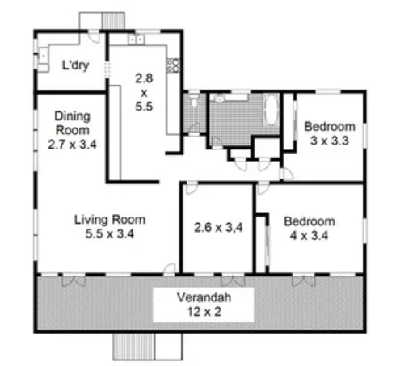

Name:___________________________________ Mark______/35

Interpret the task and gather the key information

Introductory statement about what the report will cover | 2 marks

Identify the mathematics which could help to complete the task

Statement about the key information needed to complete the task  - 2 scaled furniture layout options  - area of floor space used  - ensure 80cm wide pathway  - requirements (5 ppl living; 4ppl dining; area/dimensions of room; furniture requirements noted on task sheet) | 4 marks

Analyse information and data from a variety of sources

Reference within report body of how furniture was obtained | 1 mark
Reference section included | 1 mark

Apply their existing mathematical knowledge and strategies to obtain a solution

Report lists measurements/dimensions of furniture | 2 marks
Report outlines total area of furniture | 2 marks
Calculation of total remaining floor space | 2 marks
Report shows stepwise calculations of area of furniture | 2 marks
Furniture is represented on scale drawing with appropriate geometric convention | 2 marks
Furniture is represented on scale drawing correctly scaled | 2 marks
Two rooms are drawn to scale on scale drawing following plan on task sheet | 2 marks
Scale key noted | 1 mark
At least 80cm (drawn to scale) pathway in all two arrangements has been noted | 4 marks

Verify the reasonableness of the solution

Statement that summarises any difficulties in completing task | 1 mark
Statement about which arrangement is the better option giving reasons | 2 marks

Communicate findings in a systematic and concise manner.

Ruler used in completing scale drawings | 1 mark
Labels/key used to aid with reading of scaled drawings | 1 mark
Report set out in neat/logical format | 2 marks
Concluding statement | 1 mark

